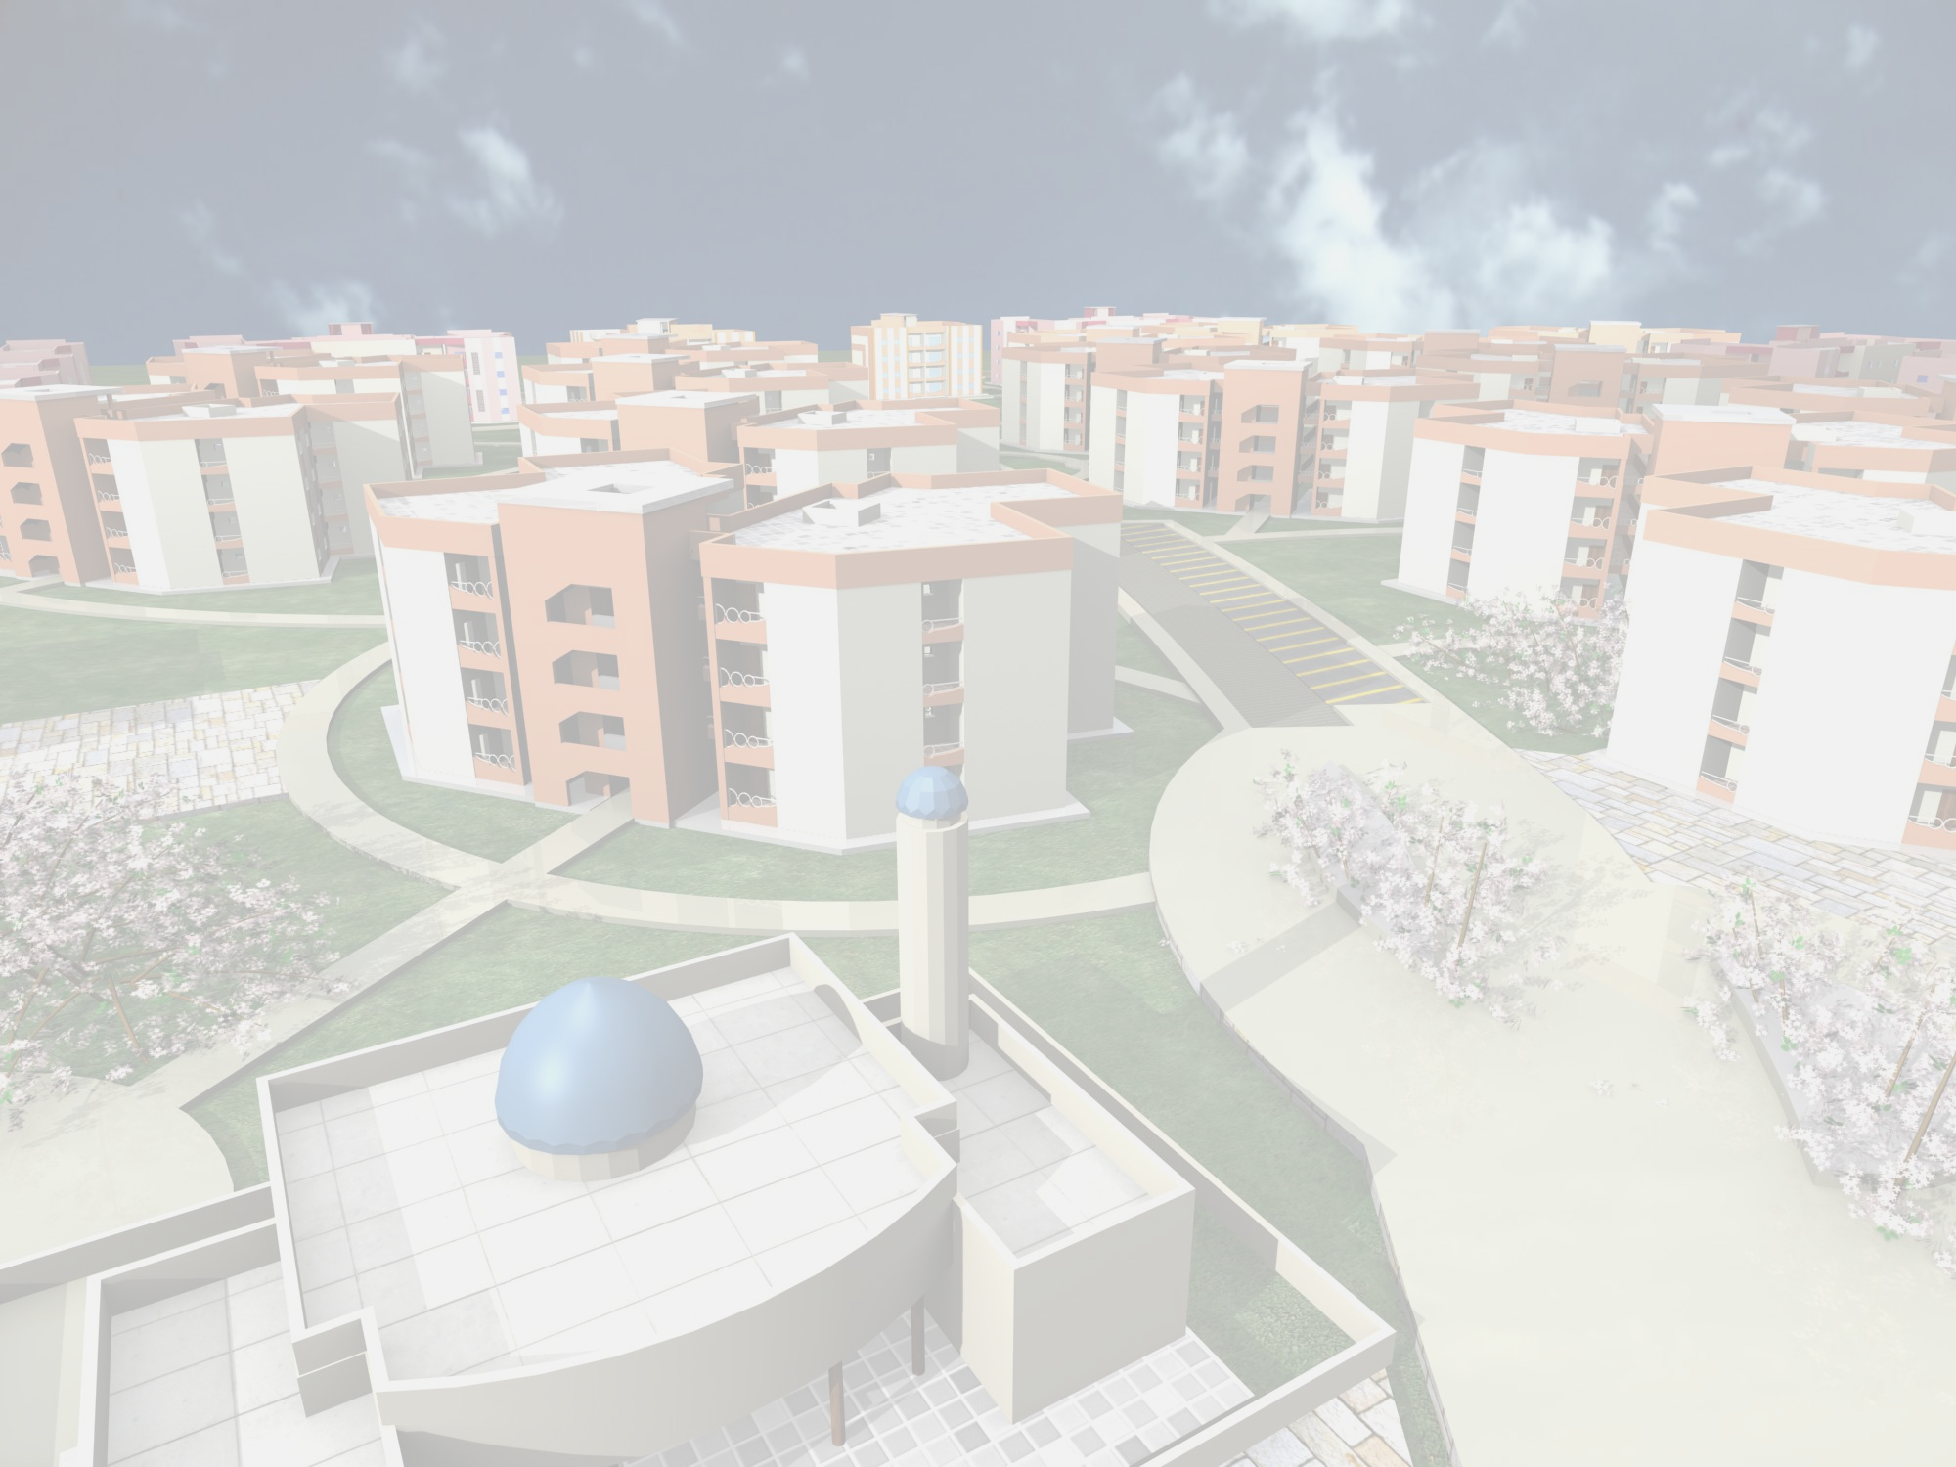
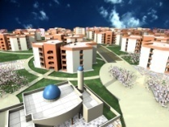
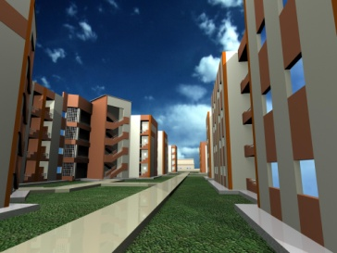
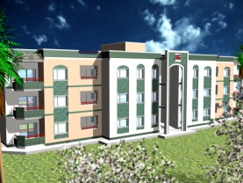
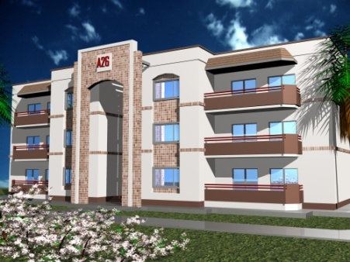
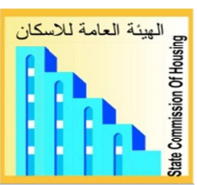
Republic of Iraq
Ministry of Construction& Housing
State Commission of Housing
Studies Section

URBAN HOUSING STANDARDS
MANUAL
OCTOBR 2010
State Commission for Housing

State Commission for Housing is one of the Ministry of Construction and Housing entities .The Commission was established at the beginning of 2001,to set and execute the general policy of housing ,and ensure the adequate housing for citizens, according to the resolution no.39/2001.
The Commission carries out:
- Suggestion of annual, phased and long term plans necessary for housing in co-ordination with the concerned parties.
- Introducing consultancy, in the field of housing studies to the state entities and private sector, in a way that ensures the execution of projects.
- Execution of general housing projects included into annual plans for housing through the companies of the ministry and private sector.
- Technical monitoring for housing projects in order to ensure the execution of programs and projects in the required quality , and according to the principles and standards adapted by the Commission.
- Assessment of the proper building technologies to execute the annual plans concerning housing projects.
- Approval of dwellings and services networks designs of housing project sites, submitted by investors of state entities and private sector.
- Participation in suggesting the regulations concerning housing.

CONTENTS
-Introduction
-How to use the manual
-Planning standards

FIRST: PLANNING INDICATORS
(1-1)Residential precinct planning indictors
(1-2)The community land use intensity indicators
(1-3)Planning indicators of community facilities
(1-4)Detailed planning indicators (population served by community facilities)
(1-5)Planning indicators of community open spaces
(1-6) Planning indicators of car (parking) spaces
(1-7)Orientation indicators ,climatic solution and shape of buildings

SECOND: DWELLING STANDARDS
(2-1)Category of dwelling
(2-2)Minimum number of habitable rooms and respective floor area
(2-3)Obligatory plot area
(2-4)Dwelling category and floor area (Urban one-family housing)
(2-5) Dwelling category and floor area (Urban multi-family housing)

THIRD: DISTANCE STANDARDS
(3-1)Minimum distance in one-family housing development
(3-2) Minimum distance in multi-family housing (up to 4 floor) development
(3-3)Other minimum distances between area development elements
(3-4)Maximum access distances from dwelling to community facilities
(3-5) Multi-family minimum plot and minimum distance

INTRODUCTION

There is no doubt about the magnificence of housing crisis in Iraq, especially in major cities centers, and this crisis can be discerned clearly in the overcrowding of dwellings,(informal) subdivisions of the residential units already-existing or plots where it is noted that the number of families that occupy one dwelling (formally subdivided ) continues to grow. Not to mention the out-dating of the housing stock is existing now and the resulting deterioration both construction wise and services-wise .Housing deficit estimated in is Iraq nearly about (2) millions housing units up the end of 2008, this figure was calculated on the basis of statistical projections of General Census conducted in Iraq in 1997, where it was not updated up to now. |  | It is a pleasure for the State Commission of Housing to introduce this concise and simple manual to be shared among bodies related to the subject of housing in all ministries, the National Investment Commission , the Mayoralty of Baghdad and the Relevant Committees in the Governorates Councils, this brochure deals with the most important planning and design criteria used by the State Commission of Housing in the preparing of detailed programs of planning and designing housing complexes .This manual is according to Article (2) of the objectives of the Commission resolution No.39 for the year 2001, the State Commission of Housing hopes to cooperate and coordinate with other relevant authorities  ( mentioned above ) in the preparation of proposals , studies and preliminary designs for the residential complexes, which are to be implemented by the public , private and cooperative sectors.
GOD, THE SOURCE OF STRENGTH

STATE COMMISSION OF HOUSING

HOW TO USE THE MANUAL

Therefore, the technical standards and recommendations contained in this manual represents in caption line to start planning and design.  On the other hand, reference to these standards could not be in the abstractly and crucial , but should be analyzed according to each case and used the best possible way to get to final solutions issuing this manual , based on those criteria will not be for this time will be continuously reviewed and updated ,to keep pace with technical they progress and general social economic. |  | This manual contains the main planning criteria required in the preparation of proposals, studies and designs of residential complexes  arranged in tables and detailed illustrative drawings they have been selected from the original documents prepared by the company  Polservice, it is necessary that the planners and designers are to noted that these criteria are merely a tool or one of the key design solutions – therefore it is required to be well-used by the professionals to get to the efficient designs as these criteria and recommendations are not an alternative for technical solutions nor a guiding engineering concise , but it is of some of the necessary elements to find design and planning solutions. Designer should choose only the basic , most relevant and appropriate items, concerning technical aspects of the project in order to develop solutions and alternatives.

* With this manual there is a CD with the original document prepared by Polservice company (in English)
and its contains information and detailed programs for planning and design of buildings, open spaces and services.
* the original document of Polservice is :
Housing Technical Standards And Codes of Practice\Report two\ Revised Edition 1983

PLANNING STANDARDS

The prevailing directions of urban planning up to a recent time adopted neighborhood concept with a service center as its heart. Then other trends arose, based on the strip of the distribution of services, in a way that interferes with the grouping system dwelling and allowing to keep economic, social and cultural activities of the neighborhood continuous and vital.  Neighborhood is called residential precinct and based on three elements number of family members, number of population and number of dwellings. By grouping four (neighborhood) a housing district is formed and grouping four districts what's called Housing sector. As to the city, it's formed by grouping four housing sectors or more.  Demographic studies depends on the average number of family members and accordingly population and the number of households is calculated  (Which means the number of dwellings, there is no doubt that the estimation of the housing need to based on housing deficit in the existing housing stock and new housing units) depends on detailed and accurate statistics. |  | And Studies carried out by the Polservice company in the seventies to prepare central Housing plan in Iraq for the period 1980-2000 are the most important and comprehensive studies in this field . it is noted that adopted certain elements and a to indicators and determinants of values different from those reached in the General Census in 1997 and the statistical projections that were calculated until 2008.  The standards and indicators in the study and used by State Commission of Housing are adjustable towards the increase up to 20% , in order to cope with the developments and current requirements.

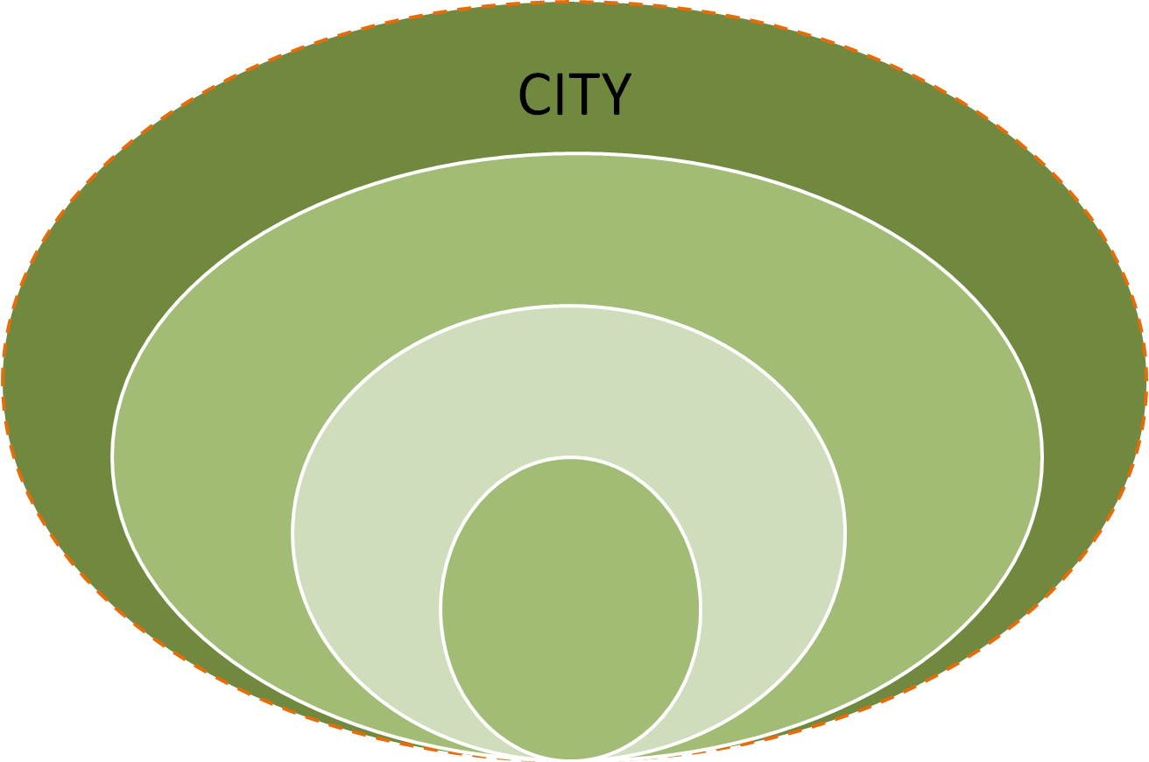
Neib.
Neib.
Neib.
Neib.
SECTOR
SECTOR
DISTRICT

DISTRICT
DISTRICT
DISTRICT
SECTOR
SECTOR

SECTOR
DISTRICT
CITY

The purpose for the planning standards is to arrange the determinants concerning the following:
- Communities :( Neighborhood, Sector, District, and City) depending on:
-Average of size of family
-Average of communities
-No. of dwellings
- Community facilities (according to the grading of communities)
- Open spaces: Green area, Parking, Play fields (according to the grading of communities)
- Type of dwellings: horizontal, vertical(no. of stories, accommodation density, depending on regulations based on master plan or sector designs.)
- The details of area and community facilities, open spaces…

Determinant:
-Communities:
To be defined the incomings standards in Paul Service study for planning the General housing in Iraq, The three elements for housing groups considered as the following:
: 1 - Neighborhood:
- Household Average (6 person).
- Dwelling Average (2400-3600 inhabitances)
- Number of dwellings (400-600 dwellings .)
*-Community social infrastructure
a-Primary school 18 classroom no .1
b-Intermediate/Secondary school 9-12 classrooms no .2
c-Local Market
d-Mosque (church)
e-Health-care center
f-Administration building
g-Nursery/Kindergarten (with job opportunities for woman)

2- Sector: is formed of 4 Neighborhoods
- Household Average (6 persons).
- Sector Average (9600-14400 inhabitances)
- Number of dwellings (1600-2400 dwellings.)
-Community social infrastructure (to be added are ):
a-Post office
b-Fire brigade station
c-Police station
d- shops(suq)
/preparatory/Vocational school e-
Note: some of these service go to the district, and it depend on the district standards

3- District: is formed of 4 sectors
- Household Average (6 persons).
- District Average (38400-57600 inhabitances)
- Number of dwellings (6400-9600 dwellings.)
-Communities:
a-Shopping center
b-Filling station
c-Car service station
d-Library
e-Cultural center

*Open areas, parks and playfield should be provided, according to age groups, and in all planning levels
Note: selection of Housing type (single-family or multi-family housing) no. of stories ,Accommodation density depends on regulations based on Master plans,
and sector designs of.

Plus
Plus
CITY

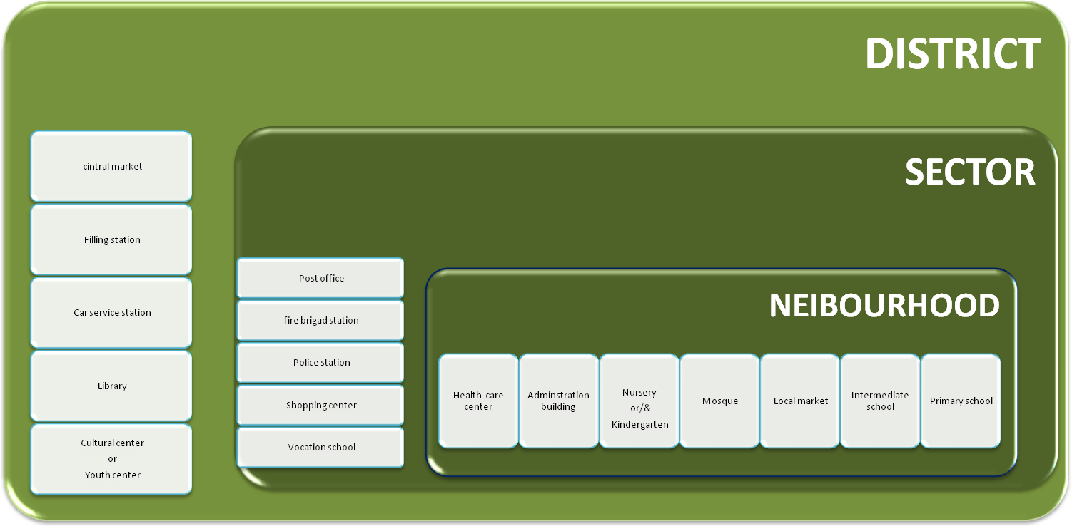

FIRST: Planning indicators

*(1-1) Indicators of planning neibourhood
Planning indicators of neibourhood depends on the type of whether , is it a single-family or multi-family ,Type of dwelling depends on:-
-Plot area
-Frontage of plot
- Minimum set-back of dwelling front line from right-of way line.
-Coverage ratio/maximum built-up area to total plot area.
-Floor area ratio/total floor area to net residential area.
-Accommodation density
-Population density
(Table 1)
*(2-1) Indicators of land use intensity
This indicator, in addition to the type of dwelling (single–family or multi-families)depends on:
- Land use balance.
-Population density and accommodation gross density.
(Table 2)
*(3-1) Indicators of planning for( social) services
This indicator according to the type of persons to be served, facilities/ nursery, kindergarten, school, elementary …etc)depends on:
- Number of persons to be served.
-Total population and children to be served.
-Total floor area.
-Maximum access distance from dwellings to facility.
(Table 3)

Residential precinct planning indicators (recommended)( Table 1)
Population net density  Inhabitants /hectare | Accommodation density/dwelling/hectare/ | Floor area ratio/total floor area to net residential area/ | Coverage ratio\maximum built-up area to total plot area\ | Recommended minimum  Set-back  Of building  Front line from right-of way line in m. | Frontage of plot \in m.\ | Plot area\in sq m\  obligatory | Type of houses
80-130  110-160  140-250  170-290 | 13-21  18-27  24-42  28-48 | 0.22-0.33  0.25-0.39  0.43-0.48  0.44-0.52 | 0.30  0.45  0.6  0.75 | 4.0  4.0  2.5  2.5/ 2 | 16-24  10-20  5-10  10-15 | 400-600 /1  300-400  200-350  150-300 | One-family houses:  - detached  -semi-detached  -row houses  -courtyard  /atrium houses
200-400  250-500 | 40-80  60-120 | 0.60-1.00  0.90-1.50 |  |  |  |  | Multi-family:  -low-rise  -high-rise

Note: 1/ Plot areas of one-family houses related to categories of dwelling are presented in chapter: DWELLINGS, HOUSES AND
RESIDENTAL BUILDINGS-(Table11)
2/If there are windows in front wall.

Floor area ratio = Total floor area
Net residential area

The community land use intensity indicators (recommended) (Table 2)
Population gross density | Accommodation gross density | Land use balance | Type of houses
150-300  100-250 | 35-70  20-60 | 0.45-0.65  0.50-0.70 | Multi-family:  -high- rise  -low - rise
50-130  80-200 | 9-21  12-32 | 0.63-0.80  0.55-0.70 | One-family:  -detached and semi-detached  - row and courtyard

Net residential area
Land use balance = _____________________
Gross residential area

Number of dwellings
Accommodation density = ____________________
Residential area

Number of inhabitants
Population density = _______________________
Residential area

Planning indicators of community facilities (Table 3)
Maximum access distance from dwellings to facility  (in m) | Total floor area  (in sq m /inh.) |  |  | Plot area –in sq m  Related to |  |  |  |  |  | Number of person to be served-per cent of total population |  |  | Facility
Maximum access distance from dwellings to facility  (in m) |  |  |  | children to be served |  |  | total population |  |  |  |  |  | Facility
300 | C | B | A | C | B | A | C | B | A | C | B | A | Nursery
300 | 0.33 | 0.160 | 0.08 | 50 | 50 | 50 | 1.0 | 0.5 | 0.25 | 2.0 | 1.0 | 0.6 | Nursery
300 | C | B | A | C | B | A | C | B | A | C | B | A | kindergarten
300 | 0.62 | 0.310 | 0.155 | 50 | 50 | 50 | 2.0 | 1.0 | 0.5 | 4 | 2 | 1 | kindergarten
500 | 0.8-1.0 |  |  | 18-23 |  |  | 3.0-3.5 |  |  | 17.5 |  |  | Primary school
500 | 0.45-0.56 |  |  | 21-26 |  |  | 1.6-2.0 |  |  | 7.5 |  |  | Intermediate school
800 | 0.42-0.5 |  |  | 21-26 |  |  | 1.4-1.7 |  |  | 6.6 |  |  | Secondary school
800 | 0.066 |  |  | 0.35 |  |  | 0.35 |  |  | 100 |  |  | Health center
800 | 0.075 |  |  | o.125 |  |  | 0.125 |  |  | For all practicing inhabitant |  |  | Mosque/church
800 | 0.12 |  |  | 2.05 |  |  | 0.67 |  |  | 33 |  |  | Cultural center
800 | 0.20 |  |  | 4.0 |  |  | 1.00 |  |  | 25 |  |  | Youth center
200 | 0.15 |  |  | 0.2-0.24 |  |  | 0.15-0.18 |  |  | 75 |  |  | Corner shop
500 | 0.48 |  |  | 1.10 |  |  | 0.83 |  |  | 75 |  |  | Local market  (suq)  or small shops
200 | 0.42 |  |  | 1.0 |  |  | 0.75 |  |  |  |  |  | Local market  (suq)  or small shops
800 | 0.48-0.50 |  |  | 1.33 |  |  | 1.0 |  |  | 75 |  |  | Shopping center
500 | 0.18 |  |  | 0.4 |  |  | 0.3 |  |  | 33 |  |  | Tea house, refreshment shop
800 | 0.198-0.2 |  |  | 0.6 |  |  | 0.3 |  |  | 50 |  |  | Restaurant ,casino
To be continued

Planning indicators of community facilities (Table 3) continued
Maximum access distance from dwelling to facility  (in m) | Total floor area  (in sq m /inh.) | Plot area –in sq m  Related to |  | Number of person to be served-per cent of total population | Facility
Maximum access distance from dwelling to facility  (in m) | Total floor area  (in sq m /inh.) | Children to be served | Total population | Number of person to be served-per cent of total population | Facility
800 | 0.012-0.024 | 0.06 | 0.06 | 100 for the whole population | Local administration
800 | 0.042 | 0.07 | 0.07 | " | Post office
800 | 0.084 | 0.1 | 0.1 | " | Police station
 | 0.012 | 0.048 | 0.048 | " | Fire brigade station/1
1600 \4 | 0.012 | 0.08 | 0.08 | " | Filling station \2
1600 \4 | 0.1 | 0.3 | 0.3 | " | Car service station \3  (4-6 stands)

Notes: communities located in an area: A-without job opportunities for women, B- with limited job opportunities for women, C- with job opportunities for women
1- One station for community or group of communities if the access time from the station in the neighboring zone is greater than 10 minutes.
2- One station per 2000 cars and not less than one in community
3- One station per 500 cars and not less than one in community
4- Recommended access distance

Community facilities plots /in hectares/ related to the exemplary community sizes (Table 4)
12000 inh. | 9600 inh. |  | 7200 inh. | 4800 inh. | 2400 inh. | Facility
0.60 | 0.48 |  | 0.36 | 0.24 | 0.12 | Nursery
1.2 | 0.96 |  | 0.72 | 0.48 | 0.24 | kindergarten
3.85 | 3.08 |  | 2.31 | 1.54 | 0.77 | Primary school
0.96*2=1.92 | 0.77*2=1.54 |  | 0.58*2=1.16 | 2*0.48=0.96 | 0.48 | Intermediate school
2*1.02=2.04 | 2*0.84=1.68 |  | 2*0.62=1.12 | 2*0.54=1.08  1*0.84 | - | Secondary school
0.42 | 0.34 |  | 0.25 | 0.25 | - | Health center
0.15 | 0.12 |  | 0.09 | 0.06 | - | Mosque\church
3*0.325=0.975 | 2*0.325=0.65 |  | 0.49 | 0.325 | - | Cultural center
1.2 | - |  | - | - | - | Youth center
- | - |  | - | - | 0.042 | Corner shop
5*0.2=1.0 | 4*0.2=0.8 |  | 3*0.2=0.6 | 2*0.2=0.4 | 0.2 | Local market  (suq)  Or small shop
1.2 | - |  | - | - | - | Shopping center
0.36 | 0.290 |  | 0.216 | 0.145 | 0.072 | Tea house, refreshment shop
0.36 | 0.290 |  | 0.216 | 0.145 | - | Restaurant ,casino
0.072 | - |  | - | - | - | Local administration
0.085 |  | 2*0.035=0.07 | 0.05 | 0.035 | - | Post office
0.12 |  | - | - | - | - | Police station
0.05 |  | - | - | - | - | Fire brigade
0.084 |  | - | - | - | - | Filling station
0.24 |  | - | - | - | - | Car service station

(Table 5) Population served by community facilities
 | Facilities
-30 days up to 3 years  -120 children per 1000 inhabitants (12 pc of total population)  -5 children per 1000 inhabitants (4 pc of age group)  -10-12 children per 1000 inhabitants (8-10 pc of age group)  -16-20 children per 1000 inhabitants (13-16 pc of age group) | 1-Nursery:  - age of children served  - assumed population characteristics  -assumed number of children served :  a- in communities without job opportunities for women  b- in communities with limited job opportunities for women  c- in communities with unlimited job opportunities for women  the number of children served may be in particular cases adjusted local needs and to the number of women employed.
-4-5 years  -70 children per 1000 inhabitants (7 pc of total population)  -10-15 children per 1000 inhabitants (14-21 pc of age group)  -15-20 children per 1000 inhabitants (21-28 pc of age group)  -25-40 children per 1000 inhabitants (35-57 pc of age group) | 2-kindergarten:  - age of children served  - assumed population characteristics  -assumed number of children served :  a- in communities without job opportunities for women  b- in communities with limited job opportunities for women  c- in communities with unlimited job opportunities for women  the number of children served may vary according to local demographic factors and local organization of educational services
-6-11years  -175 children per 1000 inhabitants (17.5 pc of total population)  -175 children per 1000 inhabitants (100 pc of age group) | 3- Primary school :  - age of children served  - assumed population characteristics  - number of pupils served :

To be continued

(Table 5) continued Population served by community facilities
-12-14 years  -78 persons per 1000 inhabitants(8.5 pc of total population)  -75students per 1000 inhabitants (96 pc of age group) | 4- Intermediate school:  - age of persons served  - assumed population characteristics  - number of students served :
-15-17 years  -80 persons per 1000 inhabitants(8 pc of total population)  -66student per 1000 inhabitants (82 pc of age group) | 5- Secondary school:*  * The number of secondary school students contains students of general schools under supervision of Ministry of Education, and student's vocational schools under supervision of other ministries.  - age of persons served  - assumed population characteristics  - Number of students served :  Note(:it refers to points 1,2,3,4,5)  Housing standards have been worked out for years 1981-2000,thus they consider predicted changes within the age structure of the population. the data obtained from 1977 national census have been averaged and also due consideration was given to the anticipated increase in attendance of children and youth to the facilities under analysis.
To be continued

(Table 5) continued Population served by community facilities
- for 100 pc of the population | 6-Health care center:  - number of persons served :
-according to local needs. | 7- Mosque , church  - number of persons served :
-330 persons per 1000 inhabitants (for 33 pc of total population) | 8- Cultural center:  - number of persons served :
-250 persons per 1000 inhabitants  (for youth from 12 up to 25 years of age; the number of inhabitants served equals 25 pc of the total population) | 9- Youth center:  - number of persons served :
-750 persons per 1000 inhabitants  (for 75 pc of the total population, excluding small children and aged people) | 10- Corner shop:  - number of persons served :
-750 persons per 1000 inhabitants  (for 75 pc of the total population, excluding small children and aged people) | 11-Local market (suq):  - number of persons served :
To be continued

(Table 5) continued Population served by community facilities
-750 persons per 1000 inhabitants  (for 75 pc of the total population, excluding small children and aged people) | 12- Shopping center  - number of persons served :
-330 persons per 1000 inhabitants  (for 33 pc of total population) | 13- Tea or coffee house, refreshment shop:  - number of persons served :
-300 persons per 1000 inhabitants  (for 30 pc of total population) | 14-Restaurant , casino:  - number of persons served :
- for 100 pc of the total population | 15- Local administration office:  - number of persons served :
- for 100 pc of the total population  (equipped with at least one telephone booth per 2,200-2,400 inhabitants) | 16- Post office:  - number of persons served :
- for 100 pc of the total population | 17- police station:  - number of persons served
- for fire protection (providing one fire brigade should serve maximum 12 thou. Inhabitants and the emergency access time should not be more than 10 minutes). | 18- Fire brigade station:  - number of persons served and purpose :

To be continued

(Table 5) continued Population served by community facilities
- supplying the inhabitants with fuel and lubricants for motor vehicles as well as gas cylinders for housekeeping purposes (one filling station should serve 12 thou. Inhabitants). | 19- Filling station:  - number of persons served and purpose :
-servicing motor vehicles (one car service station should serve 12 thou. Inhabitants) | 20- Car service station:  - number of persons served and purpose :
-150 children per 1000 inhabitants  (for 15 pc of total population) | 21- Playground:  - number of persons served
-200 children per 1000 inhabitants  (for 20 pc of total population) | 22- Playfield:  - number of persons served :
-200 persons per 1000 inhabitants  (for 20 pc of total population) | 23- Sport field:  - number of persons served :
- for recreation of all inhabitants.  . | 24- Community parks and squares:  (including sport courts)  - number of persons served and purpose :  Programmed of community facilities should be adapted to number of inhabitants of community and to the indices of population served by different facilities

(1-5)Planning indicators of community open spaces
The planning indicators of community open spaces are presented in (Table 6)
open spaces should be planned and designed on the basis of classification by age and it includes:
-fields for children's play
-sport squares for youth
-squares and car parking for all inhabitants including rest in places and sport courts

Planning indicators of community open spaces(Table 6)
Access | Max. distance of access from dwellings/in m/ | Recommended plot size in sq m |  | Area in sq.m. per one inhabitant | Age group of users | Facility
Access | Max. distance of access from dwellings/in m/ | field | total | Area in sq.m. per one inhabitant | Age group of users | Facility
crossing with access streets allowed | 200-300 | 400-600 | 600-900 | 0.75 | Children from 6 up to 11 years | playfield
crossing with collector street allowed | 500-800 | 600-1000 | 900-1500 | 0.50 | Youth from 12 up to 18  years | Sport field
crossing with collector streets allowed | 800 | - | - | 5.00 | for all inhabitants | Community park and squares/including sport courts/

Note: the sport courts(within the community park)may be used according to many considerations, including the community populations demand .
However, the user should bear the responsibility for proper maintenance of those sport courts.

(1-6) Planning indicators of car (parking) spaces
This indicator depends on:
-reference base
-number of car places
Planning indicators of car (parking) places (Table 7)
Number of car places | Reference base | Type of facility building  served
1  150 | Number of car places per one house hold or  Per 1000 inhabitants | One-family row and courtyard houses  Multi-family building
0.5  +2 | Number of car places per group of children  Number of additional places | Nursery  Kindergarten
0.5  +2 | Number of car places per one classroom  Number of additional places | Primary school and Intermediate school
1  +2 | Number of car places per one classroom  Number of additional places | Secondary school
3-6 | Number of car places per 100 sq.m..  of total floor area | Health-care center
10 | a/m | Mosque(church)
3-8 | a/m | Cultural center
3-8 | a/m | Youth center
1-2 | a/m | Corner shop
1-3  1-2 | a/m | Local market(suq) or small shop
5-8 | a/m | Shopping center
4-8 | Number of car places per 100  Consumer seats | Tea house,  Refreshment shop
3-8 | Number of car places per 100 Consumer seats | Restaurant, casino
2-4 | Number of car places per 100 sq.m..  Of total floor area | Local administration

To be continued

Planning indicators of car (parking) places (Table 7)continued
Number of car places | Reference base | Type of facility building  served
1-3 | a/m | Post office
2-4 | a/m | Police station

Note:-The area of one car (parking) place should be 25 sq m including the car turning area.
-it is possible to increase the number of car places according to needs and available site area.

The maximum access distance between car parks followings should not exceed:
- Entrances of residential building 80m
-Entrances of facility building 40m

(1-7)Orientation indicators, climatic solution and shape of buildings:
The position of the sun with respect to any point on the earth's surface is defined by the angle of azimuth and the angle of altitude. These angles, determined by the latitude, the date and the hour, play an important role in establishing orientation of building. In Iraq the latitude generally accepted for the purposes of orientation of building is 35˚ N.
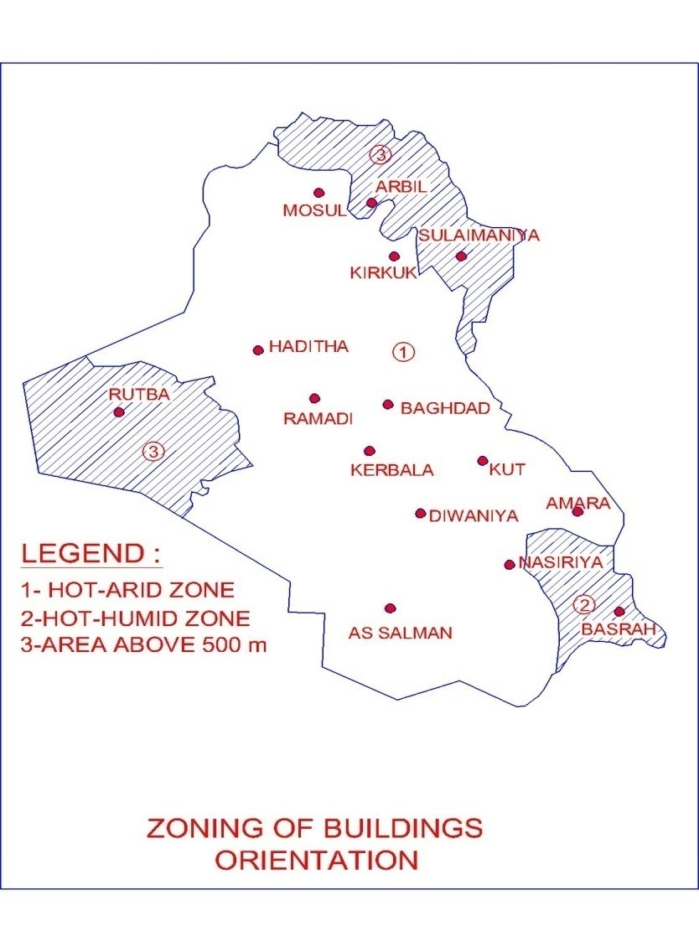
The greatest and smallest altitude of the sun within a year, receptivity, is:
1-at noon on June 22nd-78 30'
2-the best orientation of building in this area is 35˚ east from the south.
(see figure1)

-orientation in the hot town(south area):
1-at noon on December 22nd-31 30'
2-the best orientation of building in this area is 15˚ east from the south.
(see figure2)

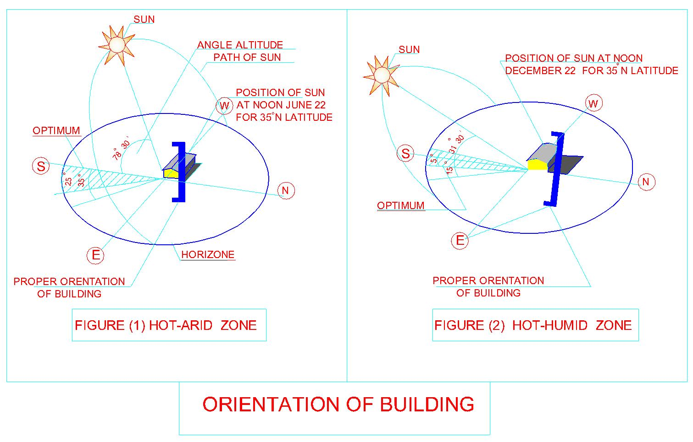

(2-1)Category of dwelling
In-door useful floor area:
In accordance with the dwelling category and type of residential building the useful indoor floor area of the dwelling comprising total of all living and auxiliary spaces is obligatory.

In-door useful floor area (Table 8)
In-door useful floor area  Of a dwelling |  | Category of  dwelling
Multi-family  housing | One-family  housing
(sq m)
57-63 | - | S1 | Small
69-75 | 75-81 | S2 | Small
93-99 | 99-105 | M1 | Medium
108-114 | 114-120 | M2 | Medium
138-147 | 147-157 | L | Large
- | 168-180 | E1 | Extra large
- | 183-195 | E2 | Extra large

(2-2)Minimum number of habitable rooms and respective floor area

According to the category of dwelling and type of residential building minimum allowable number of habitants rooms in the dwelling and minimum total floor area is as indicated in( Table 9 )

Minimum number of habitable rooms and respective floor area (Table 9)

Multi-family  housing |  | One-family  housing |  | Category of  dwelling
Minimum habitable floor area  (sq m) | Minimum number of habitable rooms | Minimum habitable floor area  (sq m) | Minimum number of habitable rooms
33 | 2 | - | - | S1 | Small
42 | 2 | 48 | 3 | S2 | Small
57 | 3 | 63 | 4 | M1 | Medium
69 | 4 | 75 | 5 | M2 | Medium
87 | 5 | 93 | 6 | L | Large
- | - | 108 | 7 | E1 | Extra large
- | - | 120 | 8 | E2 | Extra large

(2-3)Obligatory plot area:

The obligatory plot area for one-family houses is determined in (Table 10)
Plot area (in sq m) | Type of one-family houses
400-600 | Detached house
300-400 | Semi-detached house
200-350 | Row house
150-300 | Courtyard house

Regarding several categories of dwelling it is recommended to plan plot areas for small one-family houses at lower limits and
plot area for large and extra large houses at upper of the ranges determined previously as obligatory for houses of definite type

plot area for typing of dwelling (Table 11)

Recommended plot area of one-family house (sq.m) |  |  |  | Category of  dwelling
Courtyard house | Row house | Semi-detached house | Detached house | Category of  dwelling
150-210 | 200-260 | 300-340 | 400-450 | Small
170-240 | 220-290 | 320-360 | 420-500 | Medium
190-270 | 240-320 | 340-380 | 440-550 | Large
210-300 | 260-350 | 360-400 | 460-600 | Extra large

(2-4)Dwelling category and floor area (Urban one-family housing)
Dwelling categories and floor areas(Table 12)
E2 | E1 | L | M2 | M1 | S2 |  | CATEGORY OF DWELLING
11 and more | 9-11 | 7-9 | 5-7 | 3-5 | 1-3 |  | OCCUPANCY RATE  Number of persons per dwelling
6 | 5 | 4 | 3 | 2 | 1/2 |  | BEDROOMS | MINIMUM NUMBER OF ROOMS
2 | 2 | 2 | 2 | 2 | 2 |  | LIVING ROOMS
8 | 7 | 6 | 5 | 4 | 3 |  | HABITABLE ROOMS
FLOOR AREA  (sq.m) |  |  |  |  |  |  | CHARACTER OF DIRECTIVE | REQUIRED SPACE
15 | 15 | 15 | 15 | 15 | 21/12 | r.min. | master bedroom |  | 1
12 | 12 | 12 | 12 | 12 | -/9 | Ob.min. | 2-nd bedroom |  | 2
12 | 12 | 12 | 12 | - | - | Ob.min. | 3-rd bedroom |  | 3
12 | 12 | 12 | - |  | - | Ob.min. | 4-th bedroom |  | 4
12 | 12 | - | - | - | - | Ob.min. | 5-th bedroom |  | 5
12 | - | - | - | - | - | Ob.min. | 6-th bedroom |  | 6
75 | 63 | 51 | 39 | 27 | 21 | r.min. | Total of sleeping and personal activities space 1+2+3+4+5+6 |  | 7
24 | 24 | 21 | 18 | 18 | - | r.min. | 1-st living rooms or family living room |  | 8
15 | 15 | 15 | 12 | 12 | - | r.min. | 2-nd living room or guest reception room |  | 9
39 | 39 | 36 | 30 | 30 | 27 | r.min. | Total of living space 8+9 |  | 10
120 | 108 | 93 | 75 | 63 | 48 | Ob.min. | Total of habitable space 7+10 |  | 11
18 | 18 | 15 | 12 | 12 | 9 | Ob.min. | Space for preparation of food |  | 12
To be continued

E2 | E1 | L |  | M2 | M1 | S2 |  | CATEGORY OF DWELLING
OCCUPANCY RATE
Number of persons per dwelling
6 | 5 | 4 |  | 3 | 2 | 1/2 |  | BEDROOMS | MINIMUM NUMBER OF ROOMS
2 | 2 | 2 |  | 2 | 2 | 2 |  | LIVING ROOMS
8 | 7 | 6 |  | 5 | 4 | 3 |  | HABITABLE ROOMS
FLOOR AREA  (sq.m) |  |  |  |  |  |  |  | CHARACTER OF DIRECTIVE | REQUIRED SPACE
4.5 | 4.5 |  | 4.5 | 3.5 | 3.5 | 4.5 | Ob.min. | Bathroom |  | 13
3 | 3 |  | 3 | - | - | - | Ob.min. | 2-nd bathroom |  | 14
1.5 | 1.5 |  | 1.5 | 1.5 | 1.5 | - | Ob.min. | Toilet room |  | 15
9 | 9 |  | 7.5 | 6 | 6 | 4.5 | Ob.min. | Storage |  | 16
36 | 36 |  | 32 | 23 | 23 | 18 | r.min. | Total of service space 12+13+14+15+16 |  | 17
27* | 24* |  | 21* | 15 | 12 | 9 | r.max. | Circulation space |  | 18
183-195 | 168-180 |  | 147-157 | 114-120 | 99-105 | 75-81 | Ob. | USEFUL IN-DOOR SPACE 11+17+18 |  | 19
39 | 33 |  | 27 | 21 | 15 | 9 | r.min. | Out- door space for summer night rest |  | 20
221-234 | 201-213 |  | 174-184 | 135-141 | 114-120 | 84-90 | r. | Total of in-door and out-door useful space19+20 |  | 21
Note:* Including space for internal stairs

(2-5) Dwelling category and floor area (Urban multi-family housing)
Dwelling categories and floor areas(Table 13)
L | M2 | M1 | S2 | S1 |  | CATEGORY OF DWELLING
7-9 | 5-7 | 3-5 | 1-3 | 1 |  | OCCUPANCY RATE  Number of persons per dwelling
4 | 3 | 2 | 1 | 1 |  | BEDROOMS | MINIMUM NUMBER OF ROOMS
1 | 1 | 1 | 1 | 1 |  | LIVING ROOMS
5 | 4 | 3 | 2 | 2 |  | HABITABLE ROOMS
FLOOR AREA  (sq.m) |  |  |  |  |  | CHARACTER OF DIRECTIVE | REQUIRED SPACE
15 | 15 | 15 | 21 | 13 | r.min. | master bedroom |  | 1
12 | 12 | 12 | - | - | Ob.min. | 2-nd bedroom |  | 2
12 | 12 | - | - | - | Ob.min. | 3-rd bedroom |  | 3
12 | - | - |  | - | Ob.min. | 4-th bedroom |  | 4
- | - | - | - | - |  | 5-th bedroom |  | 5
- | - | - | - | - |  | 6-th bedroom |  | 6
51 | 39 | 27 | 21 | 12 | r.min. | Total of sleeping and personal activities space 1+2+3+4+5+6 |  | 7
30 | 24 | 24 | 21 | 21 | r.min. | Multi-purpose living room |  | 8
- | - | - | - | - |  | 2-nd living room |  | 9
30 | 24 | 24 | 21 | 21 | r.min. | Total of living space 8+9 |  | 10
87 | 69 | 57 | 42 | 33 | Ob.min. | Total of habitable space 7+10 |  | 11
15 | 12 | 12 | 9 | 9 | Ob.min. | Space for preparation of food |  | 12

To be continued

Dwelling categories and floor areas(Table 13)continued

L-Large Small; M1, M2-Medium; S1,S2- Note:
L | M2 | M1 | S2 | S1 |  | CATEGORY OF DWELLING
OCCUPANCY RATE
Number of persons per dwelling
4 | 3 | 2 | 1 | 1 |  | BEDROOMS | MINIMUM NUMBER OF ROOMS
1 | 1 | 1 | 1 | 1 |  | LIVING ROOMS
5 | 4 | 3 | 2 | 2 |  | HABITABLE ROOMS
FLOOR AREA  (sq.m) |  |  |  |  |  | CHARACTER OF DIRECTIVE | REQUIRED SPACE
4.5 | 3.5 | 3.5 | 4.5 | 4.5 | Ob.min. | Bathroom |  | 13
3 | - | - | - | - | Ob.min. | 2-nd bathroom |  | 14
1.5 | 1.5 | 1.5 | - | - | Ob.min. | Toilet room |  | 15
7.5 | 6 | 6 | 4.5 | 3 | Ob.min. | Storage |  | 16
31.5 | 23 | 23 | 18 | 16.5 | r.min. | Total of service space 12+13+14+15+16 |  | 17
18** | 15 | 12 | 9 | 6 | r.max. | Circulation space |  | 18
138-147 | 108-114 | 93-99 | 69-75 | 57-63 | Ob. | USEFUL IN-DOOR SPACE 11+17+18 |  | 19
15-24* | 12-18* | 9-12* | 6 | 3 | r.min. | Out- door space for summer night rest |  | 20
153-171 | 120-132 | 102-111 | 75-81 | 60-66 | r. | Total of in-door and out-door useful space 19+20 |  | 21

R.min-recommended minimum;-ob-obligatory; ob.min - obligatory minimum; ob.max- obligatory maximum.
* First indicator for dwelling in high-rise residential building second indictor for dwelling in low-rise residential building
** in marionettes circulation floor area may be increased by 3 sq m for placing stairs.

THIRD: DISTANCE STANDARD

(3-1)Minimum distance in one-family housing development
In one-family housing development the minimum distance between the houses should be:
- Across the access12m
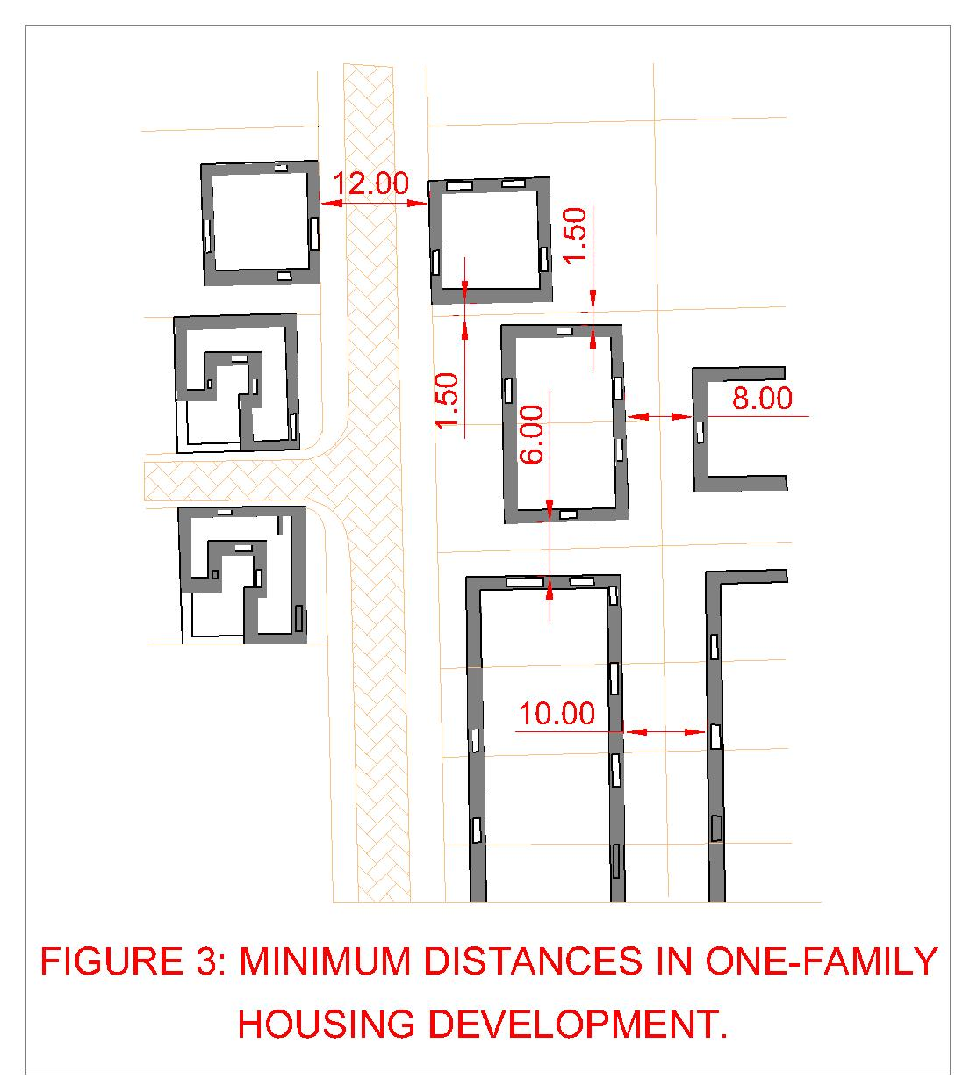
- Across the service (occasional) street for courtyard houses 6m
- Between the rear elevations of detached and semi-detached houses 6m
- Between elevation of row houses 8m
- To the boundary of the next plot for detached and semi-detached houses 1.5m

(3-2) Minimum distance in multi-family housing (up to 4 floor) development
In multi-family housing development with building up to 4 storey's high the minimum distance should be:
- between longitudinal elevations 12m
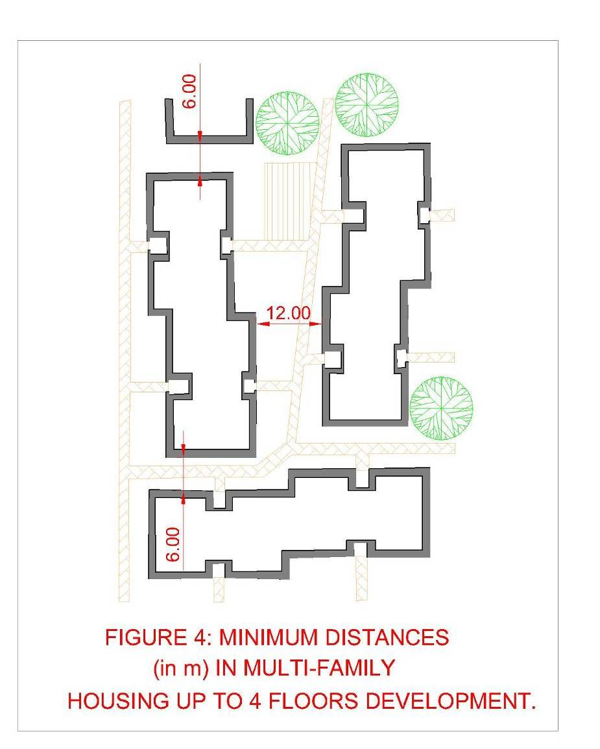
- between secondary elevations 6m

(3-3)Other minimum distances (in m) between area development elements
Minimum distances from residential building to the areas or facilities specified below are as follows
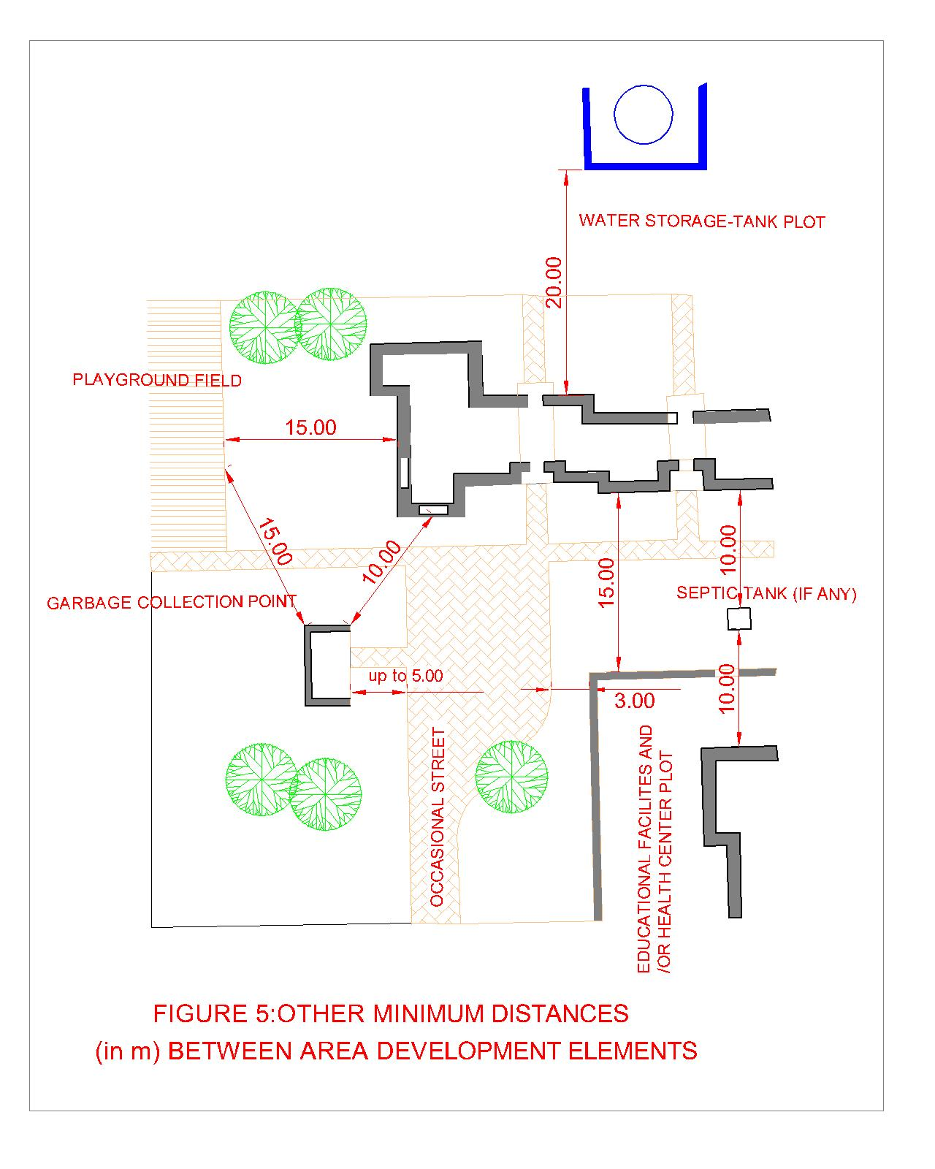
- Nursery, Kindergarten, primary and secondary schools and health center plots= 15m
- Community playground and playfields=15m
- Garbage collection point=10m
- Septic tank=10m
- Water storage tank=20m
- Car filling station=30m
- Car service station:
Up to 10 stands=25m
Over 10 stands=30m
- Boundary of the railway area=30m
- Cemetery boundary=50m
Some other minimum distance between area development elements are presented in Fig. 5

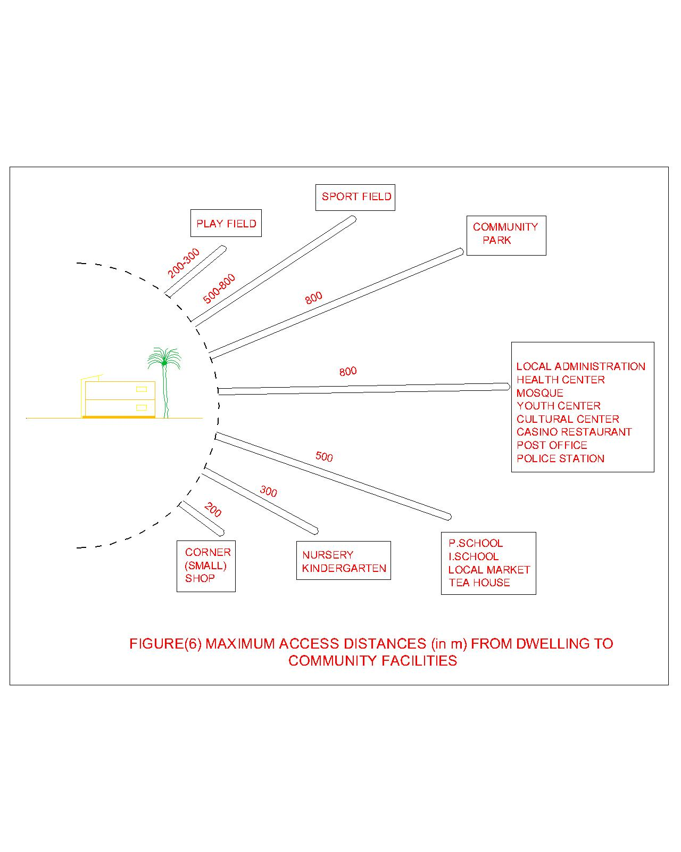
(3-4)Maximum access distances (in m) from dwelling to community facilities
Maximum access distance (in m) from dwelling to community facilities:
- Maximum access distance between dwelling and play field= (200-300m)
- Maximum access distance between dwelling and sport field= (500-800m)
- Maximum access distance between dwelling and community park= (800m)
- Maximum access distance between dwelling and (Local administration, health
Center, mosque, cultural center, casino, restaurant, post office, police station) =800m
- Maximum access distance between dwelling and (Maximum access distance
between dwelling and P. school, I. school, Local market, Tea house) =500m
- Maximum access distance between dwelling and Nursery, Kindergarten=300m
- Maximum access distance between dwelling and Corner (small) shop=200m

(3-5) The Standards For Minimum Spaces Between Housings building (multi-families) and neigh borings
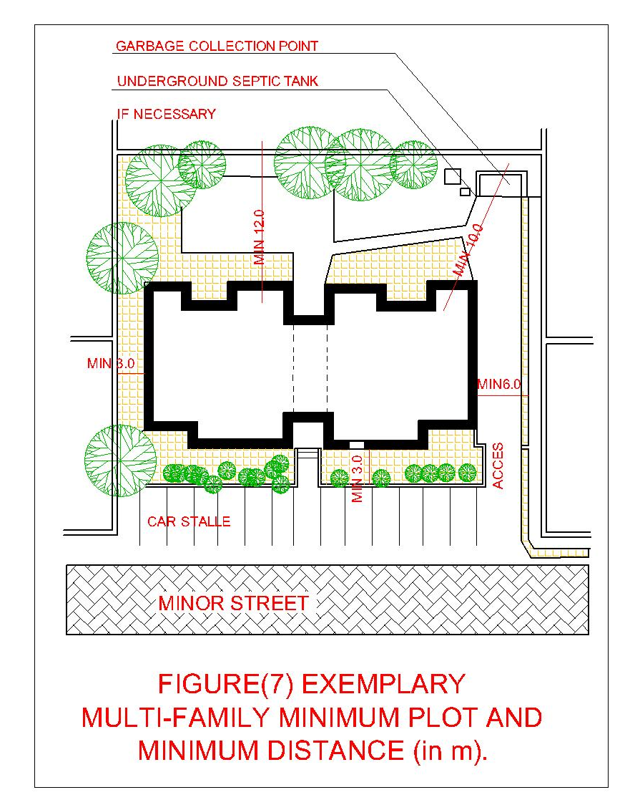
- The minimum distance between plot area and garbage collection point=10m
- The minimum distance between plot area and underground septic tank (if necessary) =12m
- The minimum distance between plot area and nearest fence with access=6m
- The minimum distance between plot area and walkway=3m
- The minimum distance between plot area and car stalls=3m

